

# AMERICAN INTERNATIONAL UNIVERSITY- BANGLADESH (AIUB)

**Introduction to Electrical Circuit**

**FALL 2023-2024**

**Section: L, Group: 07**

# LAB REPORT ON

# Familiarizing with the basic DC circuit terms & concepts: Introduction to laboratory equipment.

# Supervised By

## MD. SHAHARIAR PARVEZ

|  |  |
| --- | --- |
| **Name** | **ID** |
| **1.MD. Abdullah** | **22-48065-2** |
| **2.Azmir Islam Kafi** | **22-47981-2** |
| **3.Mohammad Ansar Uddin** | **22-47975-2** |
| **4.Chinmoy Guha** | **22-48056-2** |
| **5.Suvra Chakraborty** | **22-48067-2** |

***Abstract:***

In this experiment, we are going to be familiarized with the basic components of DC circuits and lab equipment. We are going to measure the resistance, voltage of the different equipment. The objective of the experiment is to know the process for measuring the resistance. All the DC terms in this experiment are being measured by the verified theory.

***Apparatus:***

1. Trainer Board
2. Voltmeter
3. Ammeter
4. AVO meter or Multi meter
5. DC source
6. Resistors

***Circuit Diagram:***

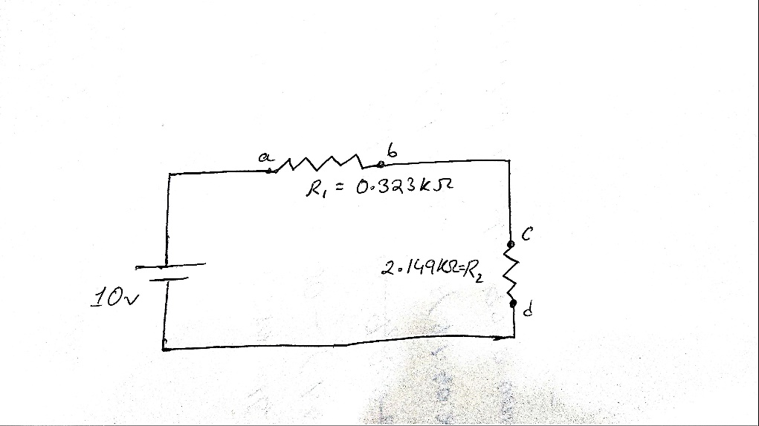

**Experimental Data and Procedure:**

1. We have calculated the values of the supplied resistors using the color code chart theoretically. Afterwards we created a circuit containing 2 of our selected resistors and then we measured the values using a multimeter. The diagram of that circuit is given above. The following table has been completed with their values –

|  |  |  |
| --- | --- | --- |
| **Resistor** | **Value Using Color Code Chart** | **Value Using Multimeter** |
| R1 | 95~105 | 97.5 Ω |
| R2 | 950~1050 | 984 Ω |
| R3 | 313.5~346.5 | 323 Ω |
| R4 | 9500~10500 | 9,830 Ω |
| R5 | 2090~2310 | 2,149 Ω |

1. Theoretically we have calculated RT , I , Vab , Vcd ,Va and Vb . Again, we have calculated the same quantities using the multimeter and completed the Table – 2:

**Table – 2**

|  |  |  |  |  |  |  |  |  |  |  |  |
| --- | --- | --- | --- | --- | --- | --- | --- | --- | --- | --- | --- |
| **E** |  | **Theoretical Calculation** | | | |  | **Multimeter Reading** | | | | |
| **RT** | **I** | **Vab** | **Vcd** | **Va** | **Vb** | **I** | **Vab** | **Vcd** | **Va** | **Vb** |
| 5V | 2.472 kΩ | 2.023mA | 0.653V | 4.347V | 4.998V | 4.347V | 2.02mA | 0.649V | 4.35V | 5V | 4.35V |
| 10V | 2.472  kΩ | 4.045mA | 1.306V | 8.692V | 9.998V | 8.692V | 4.06mA | 1.298V | 8.62V | 9.90V | 8.62V |

**Theoretical Calculation:**

Here,

RT = R1 + R2 = (323+2149) Ω = 2472 Ω = 2.472 KΩ.

For,

E = 5V

I = V/ RT = 5V/ 2.472 KΩ = 2.023mA

Vab = I × Rab = 2.023mA × 3.230KΩ = 0.653 V

Vcd = I × Rcd = 2.023mA × 2.149KΩ = 4.347 V

Now

Vcd = Vc - Vd

⟹ Vc = Vcd + Vd

⟹ Vc = 4.347 V

And

Vb = Vc = 4.347 V

Again,

Vab = Va – Vb

⟹ Va = Vab + Vb

⟹ Va = 0.653V + 4.347V

⟹ Va = 4.998V

For,

E = 10V

I = V∕ RT = 10V∕ 2.472 KΩ = 4.045mA

Vab = I × Rab = 4.045mA × 3.23KΩ = 1.306V

Vcd = I × Rcd = 4.045mA × 2.149KΩ = 8.692V

Now

Vcd = Vc - Vd

Vc = Vcd + Vd

Vc = 8.692 V

And

Vb = Vc = 8.692 V

Again,

Vab = Va – Vb

Va = Vab + Vb

Va = 1.306V + 8.692V

Va = 9.998V

**Simulation**:

We have used the NI Multism Software to get the Multimeter reading. The results are given below:  
  
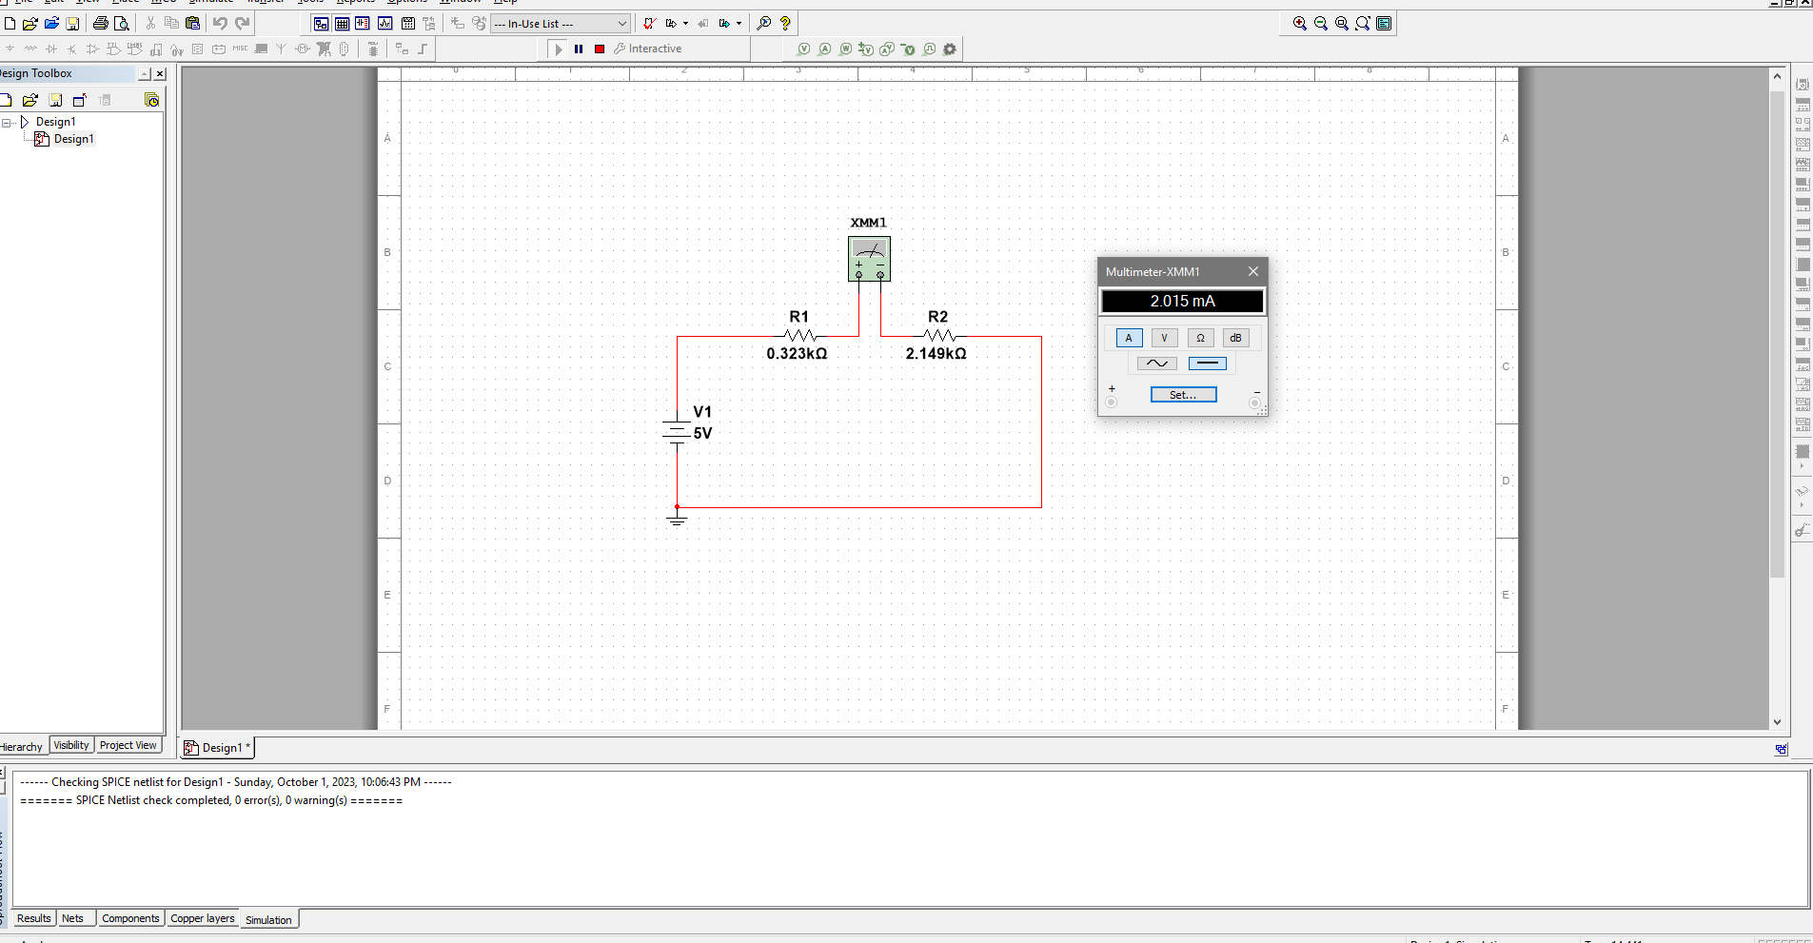

Figure: For 5V, the value of I

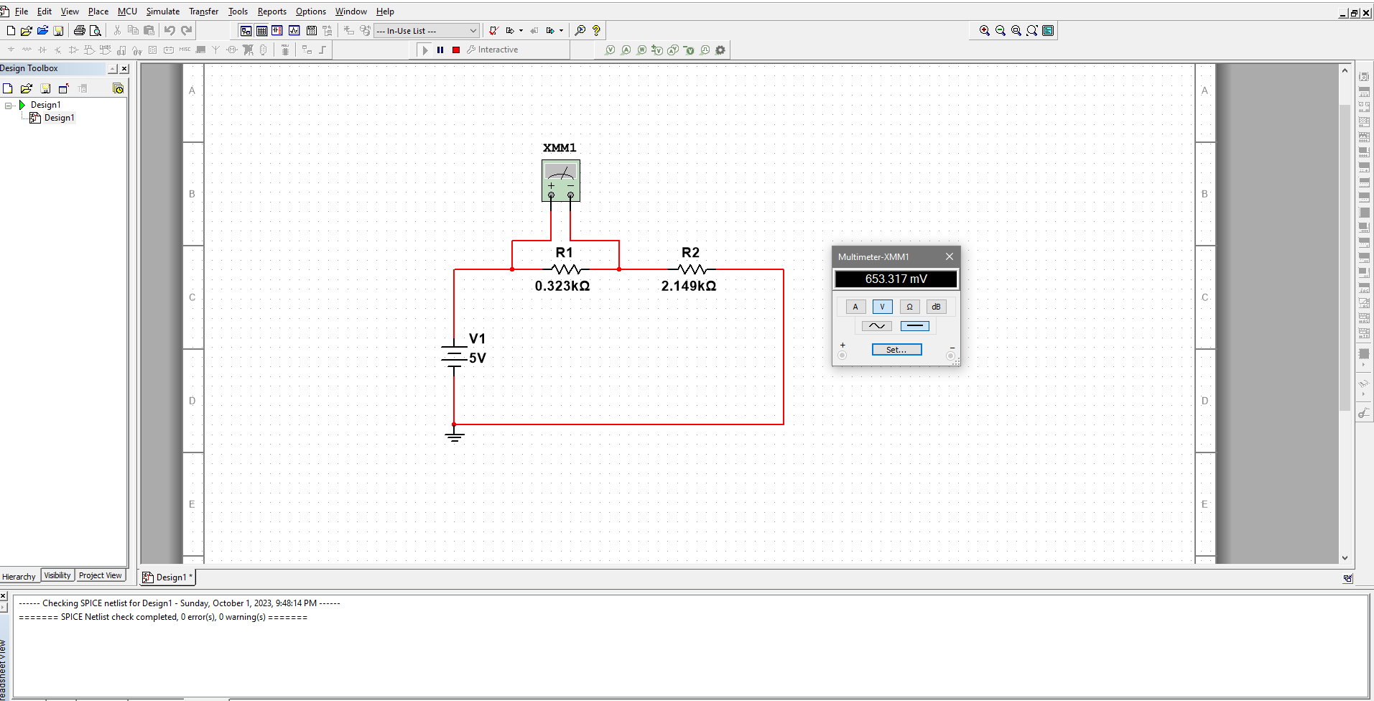

Figure: For 5V, the value of **Vab**

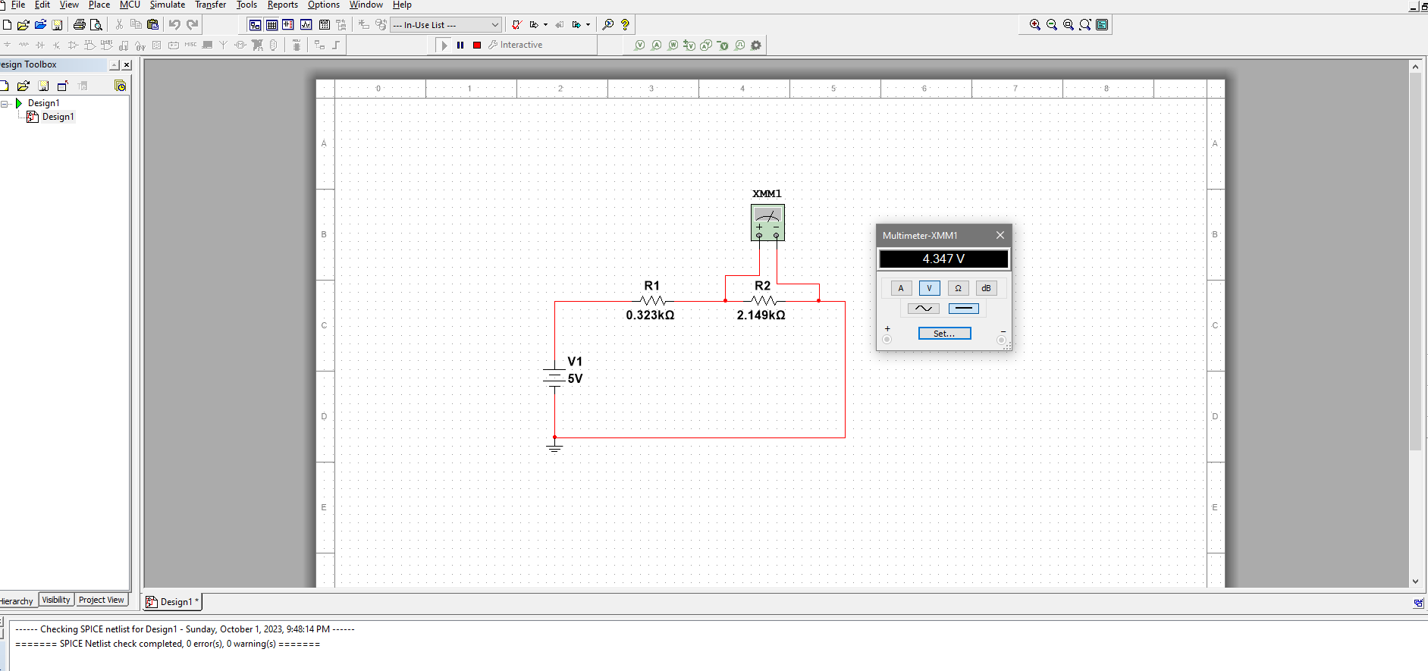

Figure: For 5V, the value of **Vcd**

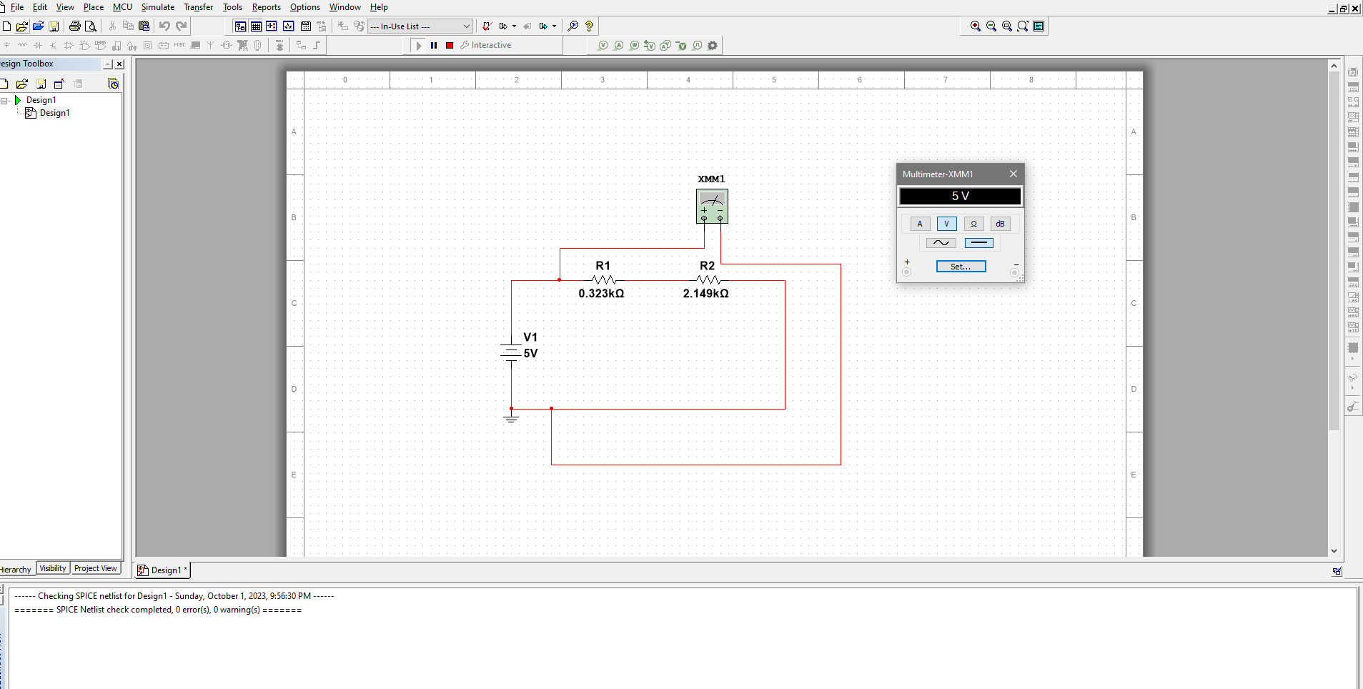

Figure: For 5V, the value of **Va**

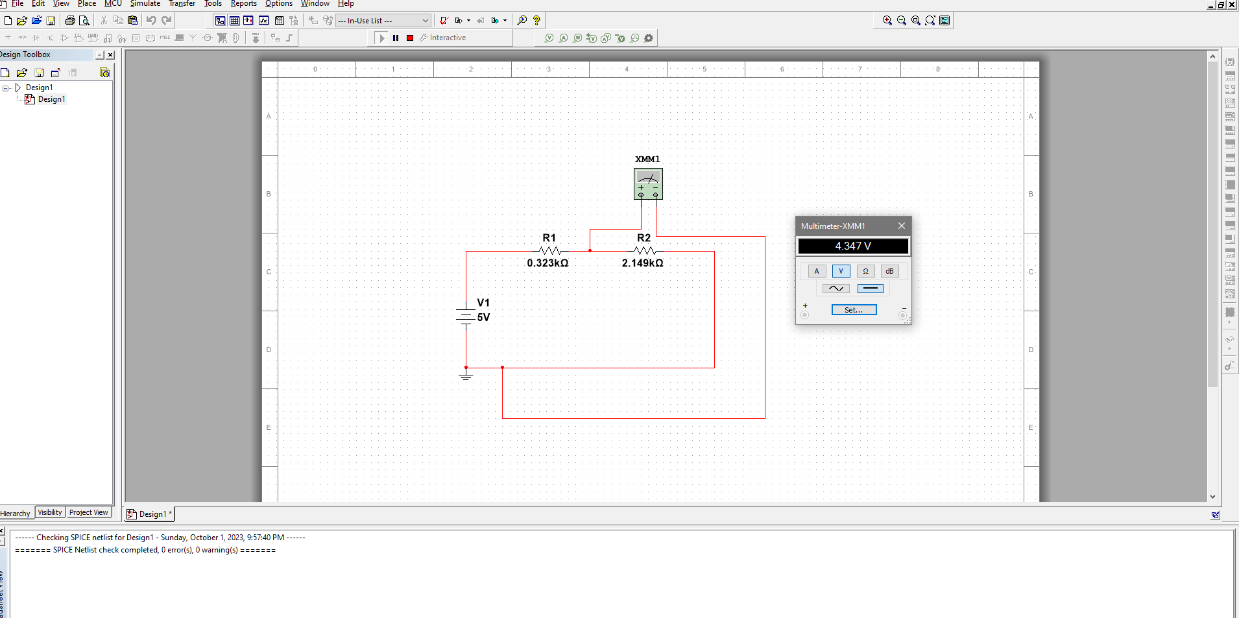

Figure: For 5V, the value of **Vb**

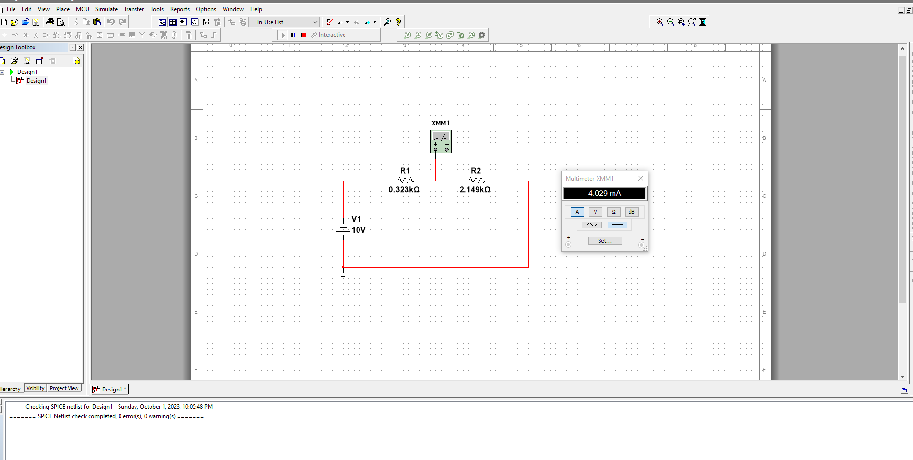

Figure: For 10V, the value of I

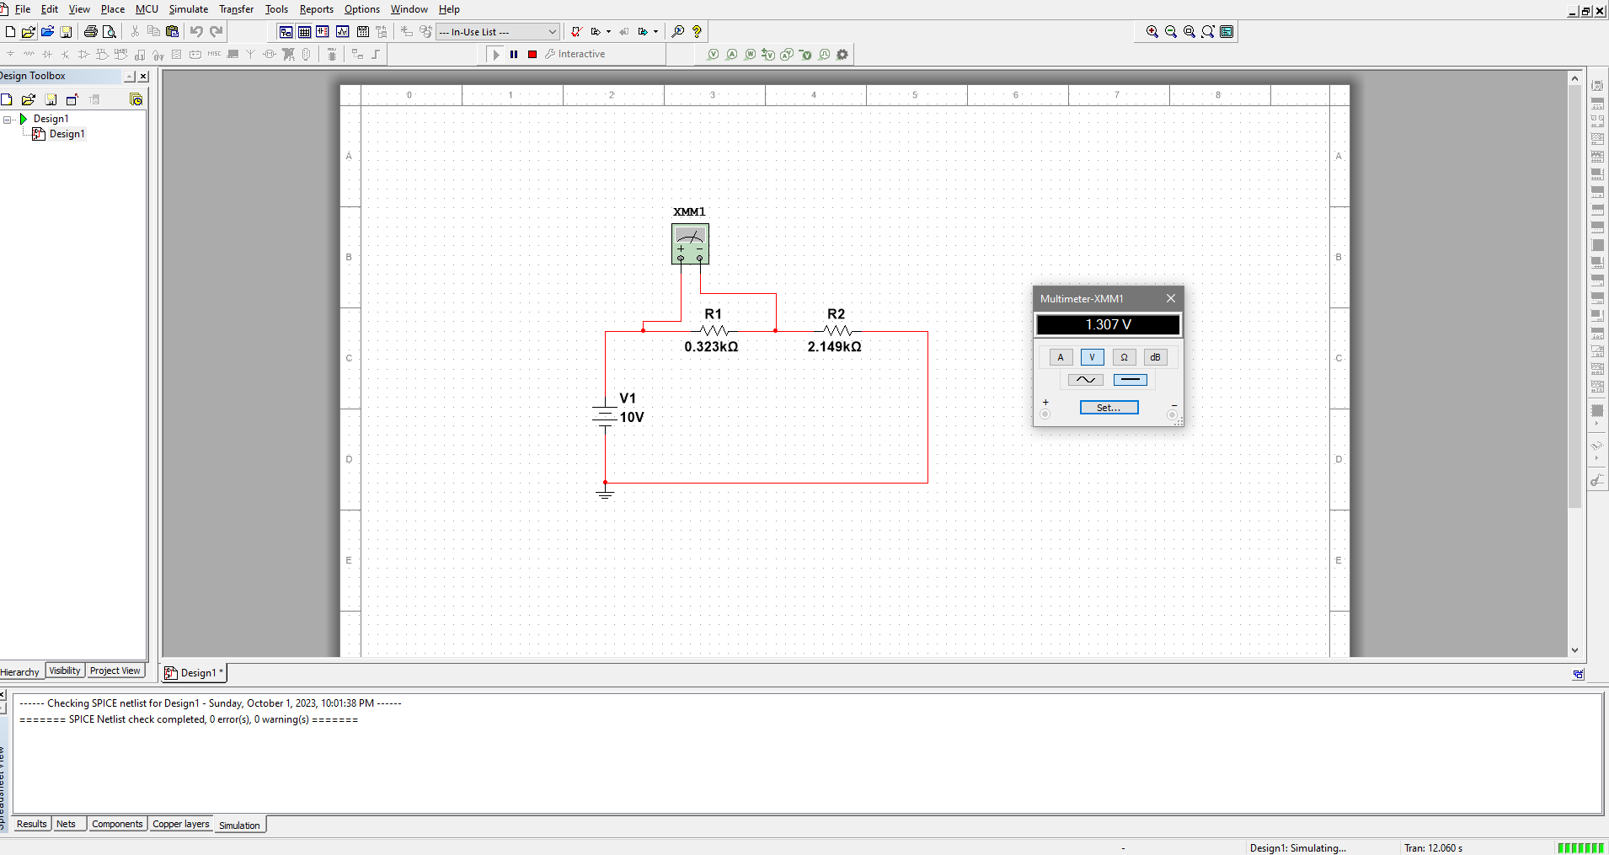

Figure: For 10V, the value of **Vab**

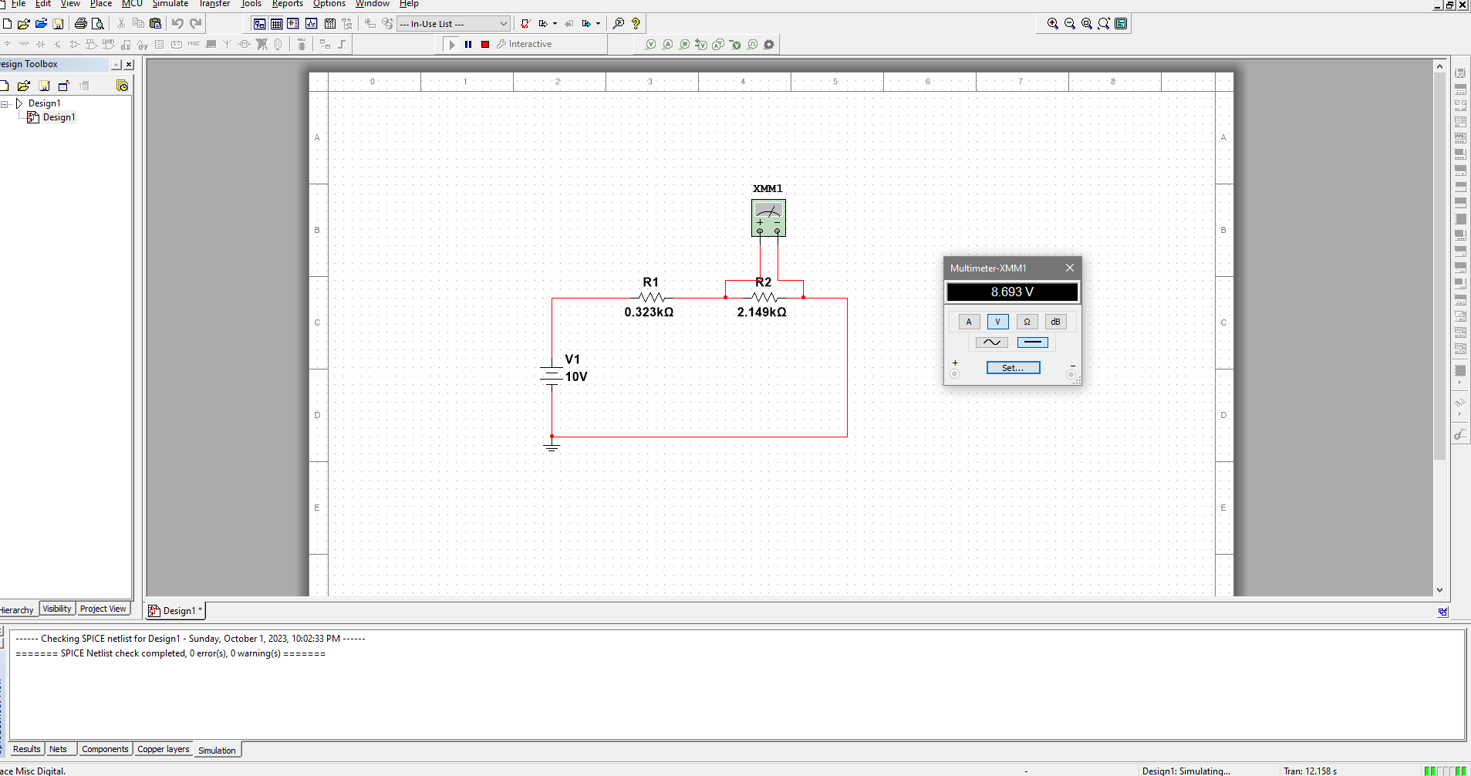

Figure: For 10V, the value of **Vcd**

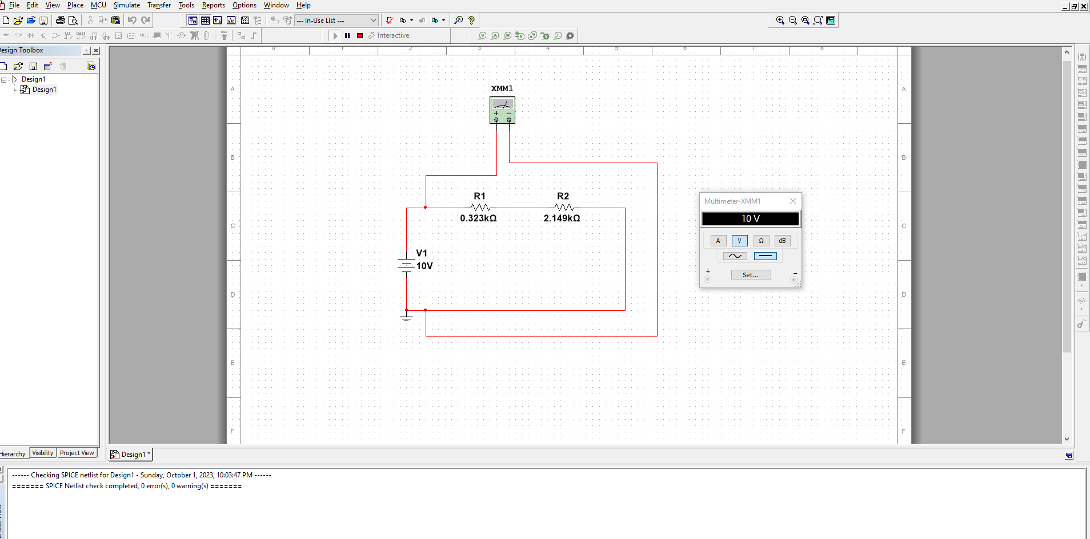

Figure: For 10V, the value of **Va**

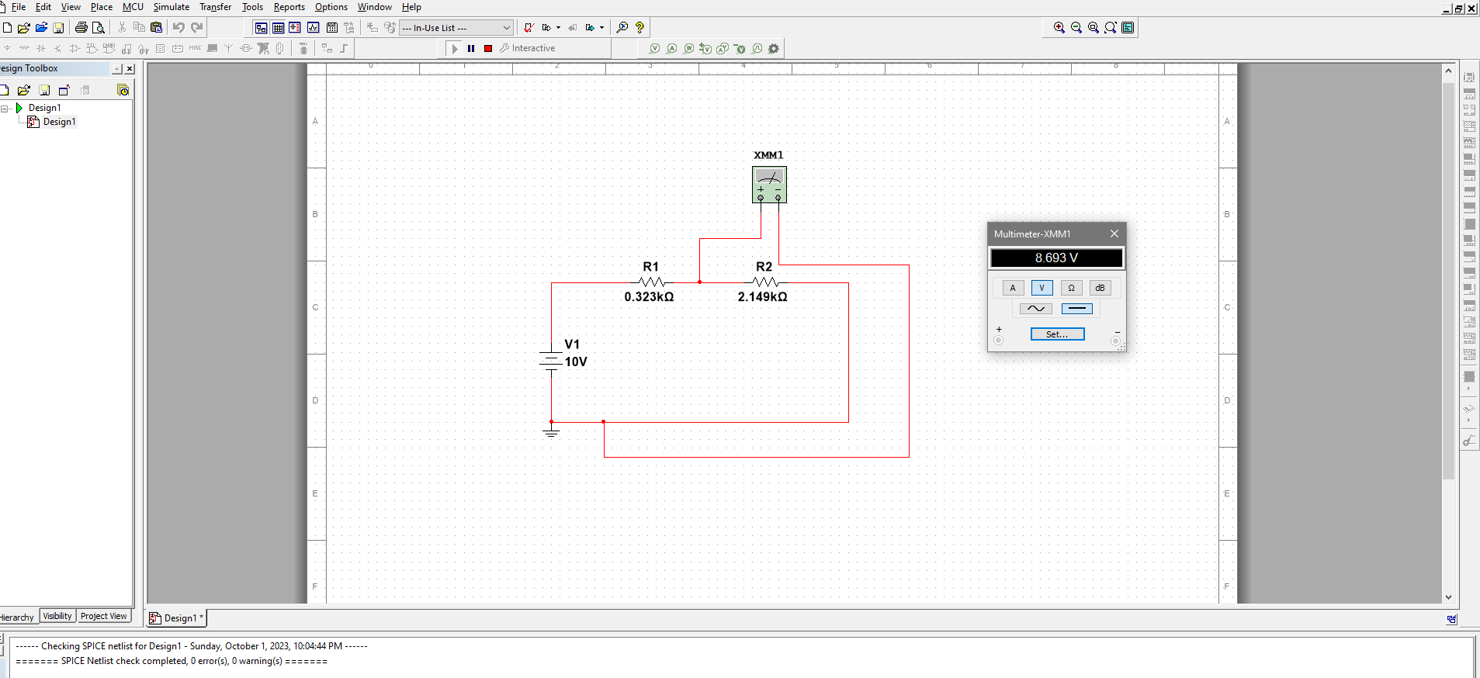

Figure: For 10V, the value of **Vb**

**Discussion**:

In the lab, we familiarized ourselves with basic DC circuit terms and concepts, by using laboratory equipment during our practical sessions. We calculated the values of our resistors using theoretical values from the color code chart provided in the sample and then made our own circuit in the breadboard to measure those resistors.   
  
For the first part of the calculations and measurements, we found that our resistor’s actual value fell right inside the range we calculated from the color chart.

However, in the 2nd part of the calculations for the 2nd table we found out that there are slight differences in our calculated values and measured values. Now this could be due to experimental errors or due to tolerance of the resistors. Also the temperature is also an issue here since in practical use, it’s not really going to be constant. The power supply providing voltage to the circuit may not be perfectly stable and we cannot forget that in practical use, the wires themselves will have resistance. It can have small fluctuations or noise that affect the voltage supplied to the circuit. So there are many reasons for the difference altogether.   
But overall, they are pretty close to the theoretical values and thus it proves that our experiment was successful.

**Conclusion**:

In this experiment, we gained knowledge about the fundamental parts of a DC circuit. We explored various concepts, both in theory and through hands-on practice, such as current, voltage, and resistance. These terms were applied in a specific diagram to help us understand their real-world applications.

While conducting the experiment, we did encounter some differences between the expected and actual results. These variations occurred due to errors that occurred during the experiment. However since the results found were close to the calculated values we can conclude that our experiment was indeed successful.